

**FACULTY OF EDUCATION**

END OF TRIMESTER 2 EXAMINATIONS, OCTOBER SITTING 2024

PAPER NAME : HISTORY OF EDUCATION

COURSE : CERTIFICATE IN NURSERY TEACHING

CODE : CNT 1202

TIME ALLOWED : 3 HOURS

**INSTRUCTIONS:**

* + Answer any **FOUR** questions and each question carries 20 mks
  + Do not write anywhere on this paper

**Questions 1:**

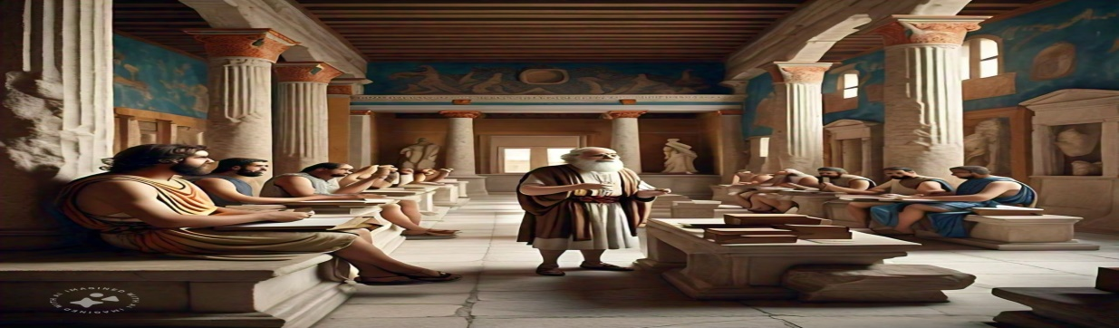

Use the image to describe the roles of teachers and students, the methods of instruction, and the subjects taught.

**Questions 2:**

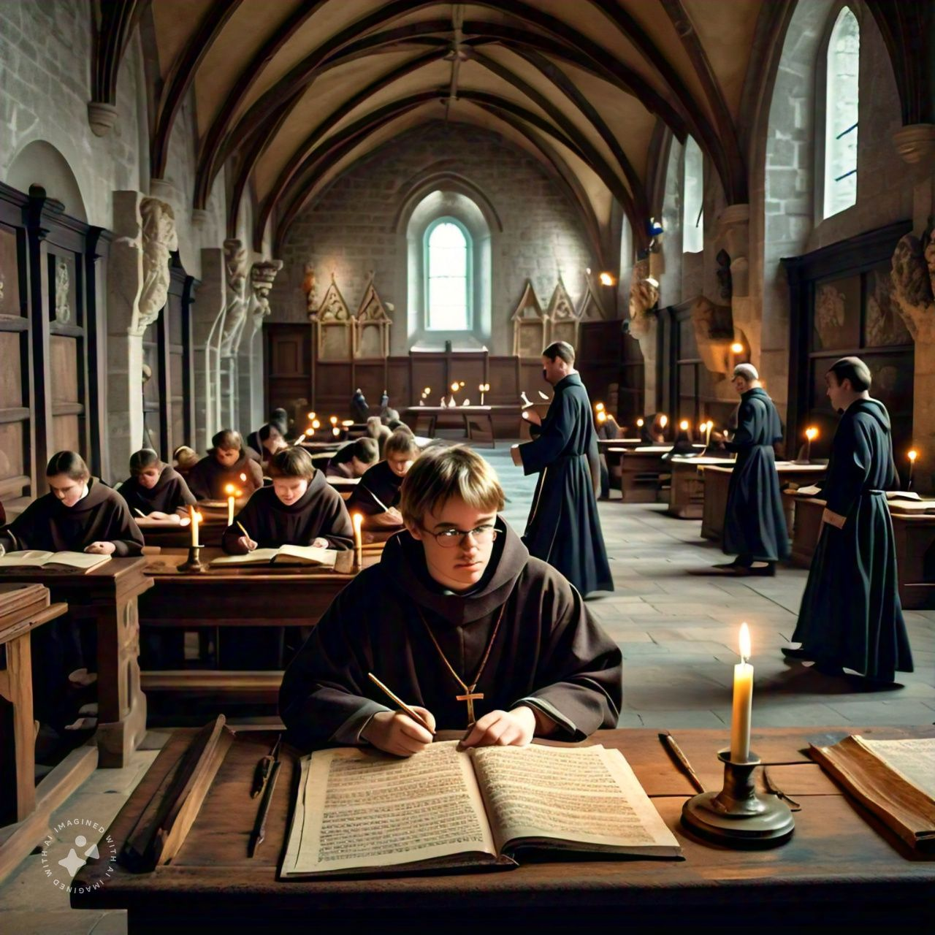

What are the key elements of education in the medieval period, and how are they represented in the image?

Questions 3: Discuss the purpose of history of education in education system

**Questions 4:**



Write the changes in education brought about formal education.

Questions 5: Discuss the problems faced by missionaries in educational transformations

**Questions 6:**Analyze the impact of technology on educational practices and outcomes